# The decline in UFO sightings continues

Published Date : July 27, 2018  
Author : cheryl-costa

The June 5 New York Skies article “[Close encounters with UFOs are getting harder to find](http://www.syracusenewtimes.com/close-encounters-ufos-getting-harder-find/)” discussed the falloff in UFO sighting reports in the United States during the early months of 2018 but only featured [National UFO Reporting Center](http://www.nuforc.org/) (NUFORC) data as a quick snapshot. At this writing, I have more interesting, and indeed serious, data to report regarding that drop-off.

Since that time, the kind folks at the [Mutual UFO Network](https://www.mufon.com/) (MUFON) have supplied me with their data for the January through June 2018 timeframe.

The MUFON sighting numbers have been suffering as well. In 2016 their average monthly sightings were between 350 and 400 per month. In 2017 sighting numbers fell between 275 and 300 reports per month. In 2018 the sighting numbers started at about 375 and bounced between 250 and 300 per month, as shown on the chart.

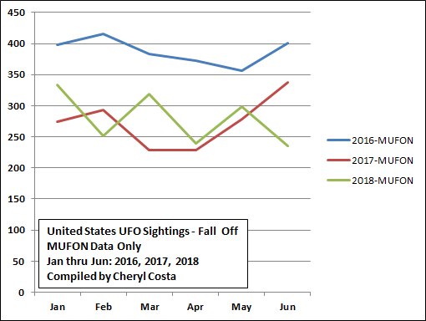

When we combine NUFORC and MUFON data we see a disturbing trend downward.

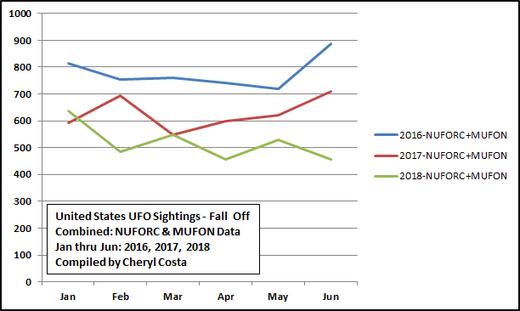

As shown in the chart, in 2016 the combined UFO sighting numbers hovered between 700 and nearly 900 per month. In 2017 the sighting numbers were down from 2016, and hovered between 260 to its lowest at 240, with a brief upsurge in June to a little over 325. In 2018, the combined sighting numbers started out at about 340 and bounced back and forth between 250 and 300, but are still heading downward.

Since the June article, I have had a great deal of social media commentary regarding this downward trend. The comments range from “The aliens don’t like us,” “People are apathetic about reporting,” and “Perhaps there’s something astronomically going on with where the aliens are from.” One comment suggested that the aliens are afraid of President Trump’s proposed Space Force.

I did an analysis of individual-shaped silhouettes of UFOs to see if all of [the 35 common-shaped silhouettes](https://www.syracusenewtimes.com/the-truth-is-in-the-ufo-shapes/) are following the downward trend. For the most part all of them have been, with two exceptions.

Square/rectangle silhouettes have been on a steady increase since 2010, while all the other common UFO silhouettes have been declining. Even the square/rectangles have shown a slight decrease in the past two years.

But one UFO that still continues to increase in sightings is the Saturn silhouette. The Saturn shape has been around for some time: One was reported in village of Norwood in St. Lawrence County, New York, in July 1833.

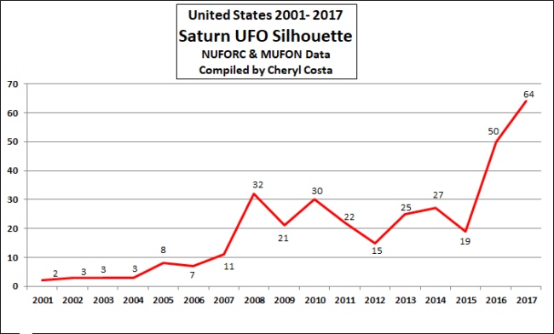

The most celebrated Saturn-shaped UFO sighting was in November 1986, when a Japanese crew of a jumbo freighter aircraft encountered such a craft that seemed to track and chase the now-famous flight JAL 1628. You can Google the flight number for details.

Who are the folks who drive these unique Saturn-shaped UFOs? It’s anyone’s guess, yet with all the other 40 UFO silhouettes in serious decline, one thing is for sure: There is a new team in town!