# Blog | Will the Hudson Valley catch another UFO wave?

Published Date : January 25, 2019  
Author : cheryl-costa

The Hudson Valley has a long history of strange paranormal occurrences. Most notable was the UFO wave of the 1980s, which began with sighting reports of boomerang-shaped UFOs in 1981. The wave of various UFO sightings peaked in 1983 and 1984 with many thousands of reports, followed by many books and documentaries about the subject.

Legendary author Whitley Strieber had his alien abduction experiences during the mid-1980s near Middletown, New York, which he wrote about in his well-known book *Communion.* The wave also led to the establishment of the Pine Bush UFO Festival in Crawford Township, which straddles Ulster and Orange counties.

Many sightings during the 1980s wave spanned the known inventory of UFO shape profiles, with boomerang and triangle shapes dominating the reportages. Yet it seems that the vast majority of eyewitnesses never formally reported what they saw to authorities. After all, services like the [National UFO Reporting Center](http://www.nuforc.org/) (NUFORC) and the[Mutual UFO Network](https://www.mufon.com/) (MUFON) weren’t established online until nearly two decades later.

Recently, science and environment reporter-editor Linda Moulton Howe said that she was getting reports that suggested UFO sightings were on the increase in the Hudson Valley “and on the scale of the 1980s.” So I spent a Saturday morning crunching numbers for key sighting counties in the Hudson Valley.

The drawback for working with UFO statistics is that you’re always dependent on past reports and recorded information. So if people don’t report their sightings to a major UFO reporting service, folks like me can’t crunch the numbers.

The 2018 NUFORC reports for New York state were only 57 percent of 2017’s numbers and 36 percent of 2015’s numbers. New York seems to be part of a serious falloff in UFO sightings being reported nationally.

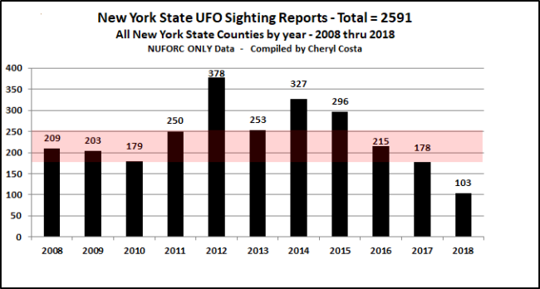

Likewise, the reported UFO sighting numbers in the southern Hudson Valley were significantly off the key counties of Columbia, Dutchess, Orange, Sullivan, Ulster and Westchester.

In 2014 and 2015, the NUFORC sighting sum for those counties was approximately 35 sightings per year, or about 31 percent tracking with the state. The same counties in 2018 logged only 11 sightings to NUFORC.

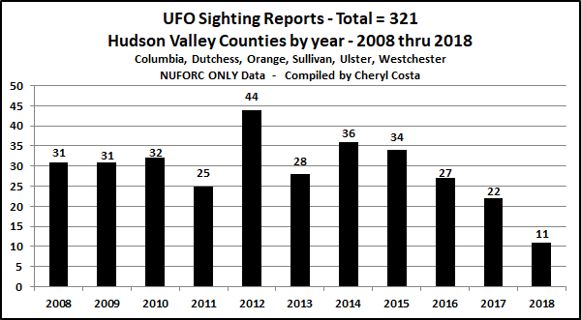

In a recent phone conversation with Hudson Valley UFO and paranormal investigator colleague Dr. C.S. Matthews, she indicated that she has received 12 reports during the past couple of weeks, and that none of them were reported to a national UFO reporting service. The UFO shapes ranged from multiple triangles, a few boomerangs, and formations of fireballs and spheres.

So the big question: Is 2019 going to be a banner year for UFOs in the Hudson Valley? This reporter can’t wait to talk to local folks at the 2019 Pine Bush UFO Festival on May 18.[snt]

*If you have a UFO sighting to report, visit the National UFO Reporting Center website, nuforc.org. NUFORC absolutely respects confidentiality.*

### On the Road in 2019

* Duke University, Durham, North Carolina, March 18-21
* UFO MEGA CON, Laughlin, Nevada, March 24-30
* Ozark Mountains UFO Conference, Eureka Springs, Arkansas, April 12-14
* Phoenix MUFON, Tempe, Arizona, May 11
* Pine Bush UFO Festival, Pine Bush, New York, May 18
* Michigan UFO Con-Tact, Houghton Lake, Michigan, Sept. 20-21
* Greater New England UFO Conference, Leominster, Massachusetts, Oct. 4-5